Nursery Curriculum Newsletter Autumn Term 2017
Dear Parents,

Welcome to Glasllwch Primary School and to our Nursery, Seren Fach. We are pleased to inform you that after their first few days at Nursery the children are coping extremely well with the routine of nursery life. We are really looking forward to working with you and your child and together we hope we can make this year an exciting, challenging and successful one. This term we will be focusing on settling your child into the routine of life in the nursery, helping them to become more independent and to become familiar with their new environment, the staff and the other children.

In order for school and home to work as a team and give your child the best start possible, below is some information about the areas we have covered in previous years. Due to the children being very young, we very much follow the interests and ideas of the children; so we are very flexible and free flowing in terms of topical interests. Below will give you a brief outline of the type of things to expect from nursery this term in replacement of a specific ‘Topic’ or project (although this is subject to change according to the interests of the children):
-Autumn
-Harvest
-Bonfire Night
-Diwali
-Christmas
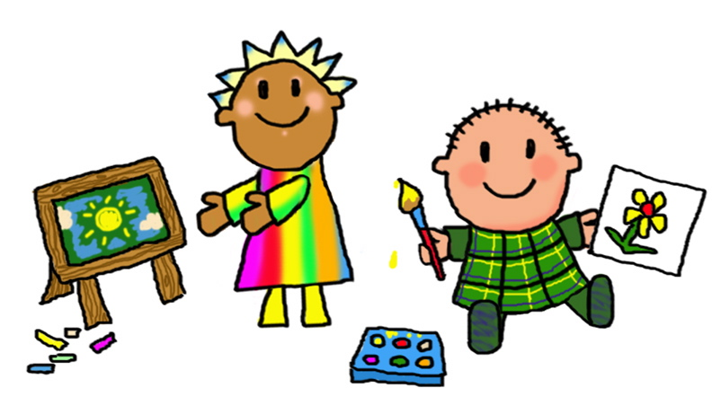

Language, Literacy and Communication Skills

For the first term children will develop their confidence and depth of language linked to specific events such as Autumn, Harvest etc. We will model asking and answering questions with the children linked to stories and responding to others. We will model and encourage group participation through play and introduce a more formal setting such as sitting in a circle for circle time. Children will develop their skills in smaller groups during their family group time, pairs, and as a whole nursery class. This will help to prepare children for the year ahead as they will become ready for Reception Class in their chosen schools.
We will then introduce children to recognising their own name, and will practise this on a daily basis.

Mathematical Development
The children will participate in daily numeracy activities, number skills will be practised in a hands on and practical way with lots of objects and fun songs/number rhymes. The children will be introduced to counting amounts up to 10, recognising numbers 1-10, recognising and describing the properties of 2D and 3D shapes, recognising the passage of time in relation to their day. They will use the language of measure when comparing size and weight and begin to use non-standard units to measure the length, height and weight of objects. Mathematical development occurs in a holistic approach mainly through play across the nursery in the role play, sand pit and other areas.

Knowledge and Understanding of the World
The school grounds will be used to observe the changes in the environment during Autumn. We will spend lots of time outdoors, particularly in our Forest School.
In their outdoor environment they will be involved in planting and taking care of plants and bulbs.

Creative Development
The children will experience a wide variety of art materials to produce topic, literacy and mathematically related artwork. They will make and decorate cakes and biscuits. They will sing a variety of songs and use the percussion instruments to accompany their singing.

Physical Development
The children will work at developing their fine and gross motor skills. Fine motor skills, through using and gaining control of writing tools, scissors etc. Gross motor skills, through gaining control of their bodies when using large/small apparatus and playing outside in the outdoor play area.

Personal and Social Development, Well Being and Cultural Diversity
The children will be supported during all aspects of nursery life. Immediately they will be introduced to routines and rules, which they will be reminded of on a daily basis. The children will be helped to develop an understanding of feelings and facial expressions. They will learn how to play and work co-operatively. They will learn to recognise their personal strengths and weaknesses. They will learn about the festivals of Harvest and Christmas.

Welsh Development
The children will be introduced to simple greetings and commands in Welsh.

Snack
At each session children are offered a drink of milk, or water and a ‘snack’. Snack varies enormously, but is always healthy! It will mainly be fruit and raw vegetables but can include cheese, dips and bread sticks, cereals and toasted goods.

Framed Family Photograph- Please could you send in a framed family photograph to leave in the nursery, we spend a lot of time talking about and showing our families in nursery.

Wellington boots- Please could you send in a pair of Wellington boots clearly labelled with your child’s name as soon as possible as we will be using the outdoors in all weathers.

Harvest
We will invite you into nursery to watch your child participate in a small Harvest Festival! Keep a look out for the date which will be published shortly.

We hope you find the above information useful. If you have any queries, please do not hesitate to contact us. You can also follow us on Twitter: @glasnursery. Thank you in anticipation of your co-operation.

Ellie McArdell and Sue Martin

